Test Description: Smoke Test for Travel Maker App
Verify basic functionality of the Travel Maker app
Test Run Information:  Tester Name: Ariel Dotan  Date of Test: 23/11/2023 | Prerequisites for this test: Internet Connection, android phone
Software Versions: Android UI 5.1
Application: Travel Maker
Browser: None
Operating System: Android
 | Required Configuration: None
NOTES and RESULTS:
This app shows your weather in your location, or you can choose other location with google maps.

TEST SCRIPT STEPS/RESULTS
STEP | TEST STEP/INPUT | EXPECTED RESULTS | ACTUAL RESULTS | Requirements Validated | PASS/FAIL
System- Smoke
 | Open Google Store App | Google Store app will be opened and will allow to search apps | Google Store App is opened without errors and allows to search apps | None | PASS
 | Click on Search bar  | Search bar is clickable and will allow to search any type of input | Search bar is clickable and allows to search any type of app without errors | None | PASS
 | Type “Travel maker” | Search bar will allow to type travel maker without errors | Search bar is allows to type travel maker without errors | None | PASS
 | Press Enter | The entered search information will be saved when press "enter"  and will direct us to the results about the information entered without problem | The entered search information is saved when pressing "enter"  and directed us to the results about the information entered without problem | None | PASS
 | Tap on the app icon 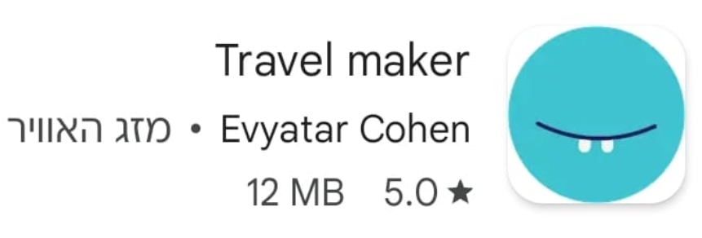 | The intended app will appear, and can click on it to install and get more information without an error | The intended app appears, and can click on it to install or get more information without an error | None | PASS
 | Click on “Install”  | The 'Install' button will appear, enabling to click on it. Once the download is complete, an app icon will be created. | The 'Install' button is appears, enabling to click on it., an app icon is created. | None | PASS
 | Click Open  | Open Button will be clickable and will direct to the app without errors | Open button is clickable and directs to the app without errors | None | PASS
 | Click on “Give permissions”  | A pop up will appear asking for “Give permissions” | A pop up is appear asking for permissions | None | PASS
 | Click “Allow” | The allow button will be clickable and will direct to the home screen app. | The allow button is clickable and directs to the app home screen | None | PASS
 | Verify weather in location associated with phone location | Home screen will show the weather associated with the phone location without errors | Home screen shows the weather associated with the phone location without errors | None | PASS
 | Click on “Maps”  | Maps button is clickable and will direct to maps for selecting specific area | Maps button is clickable and directs to maps for selecting specific area | None | PASS
 | Type “Holon” | Search field is clickable and will allow to type “holon” without errors | Search bar is clickable and allows to type “holon” without errors | None | PASS
 | Click on “Show weather” 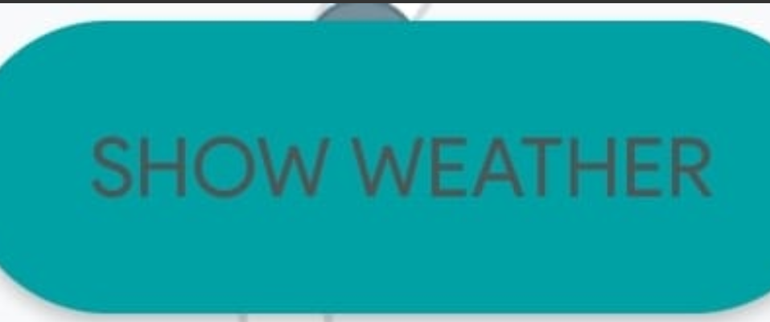 | Show weather button is clickable and will show the weather in the selected area | Show weather button is clickable and shows the weather in the selected area | None | PASS

